

Specification

for

SQL diagnostic manager 5.1 – Alert Based on Past Performance

Kurt Goolsbee

10/09/2007



Proprietary and Confidential to BBS Technologies, Inc.

© 2006 BBS Technologies, Inc.; all rights reserved.

Revision history:
When? | Who? | What?
10/09/2007 | Kurt | Initial Draft
11/16/2007 | Kurt | Second Attempt
12/03/2007 | Kurt | Final Changes

Table of Contents
1. Revision history: ii
2. Table of Contents iii
3. Requirements 1
3.1. Overview/Purpose 1
3.2. Target Users 1
3.3. Features/Function Market Requirements 1
3.3.1. Required Functions 1
3.3.2. Non-Supported Function 1
3.4. Open Issues 2
4. Functional Design 2
4.1. User Interface 2
4.1.1. Alert Configuration Dialog 2
4.1.2. Baseline/Alert Wizard 3
4.2. Installation and Upgrade 6
4.3. Permissions and other Required Configuration 6
4.4. Licensing Issues 7
4.5. Dependencies 7
4.5.1. Dependencies on Idera Software 7
4.5.2. Third-Party Software Required on the Customer Machine 7
4.5.3. Third-Party Software Required Internally 7
5. Internal Design 7
5.1. Architecture 7
5.1.1. Repository Changes 7
5.1.2. Management Service 7
5.1.3. Collection Service 7
5.1.4. Alert Configuration Dialog 8
5.1.5. Baseline Wizard 8
5.2. Installation Issues 8
5.3. Schedule 8
5.3.1. Work Breakdown and Sizings 8
5.3.2. Areas of Risk 9
6. Quality Assurance Considerations 9
6.1.1. Overview 9
6.1.2. Developer-Created Unit Tests 9

Requirements

Overview/Purpose
The purpose of this feature is to provide users assistance in configuring their alert thresholds using data collected from their monitored servers. This feature is needed for the following reasons:
- Users of DM 5.0 are going to be besieged with alerts in the new GUI and its very difficult, if not impossible, for them to know how to set each threshold on each servers.
- Users don’t know what is normal for their servers so its hard to set thresholds
- Servers can have very different “normal” ranges and configuring alerts to account for this is VERY time consuming

Target Users
This feature appeals to all customers and potential customers. It reduces the intelligence needed to properly configure alert thresholds so that alerts are only generated when the value for a metric exceeds its normal value range.

Features/Function Market Requirements

Required Functions

Set a baseline for a monitored server
Allow the user to specify a period of time that the monitored server was running under a normal workload. Calculate and store the average and standard deviation for a list of metrics during the baseline period.

Configure alert thresholds using a baseline
Allow the user to easily set alert thresholds based on values calculated from the baseline.

Non-Supported Function

Multi-Server Support
The ability to calculate a baseline and to configure the alert thresholds for multiple servers at the same time is not supported.

Open Issues

Functional Design

User Interface

Alert Configuration Dialog
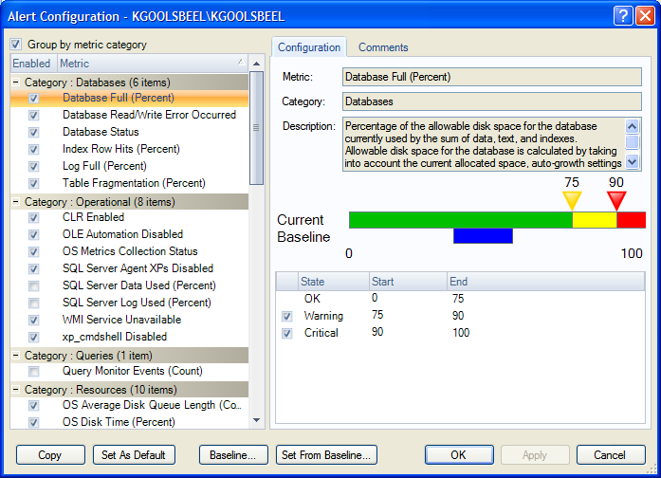
The Alert Configuration Dialog will have a single new button added to launch the wizard that will assist the user in setting alert thresholds using the baseline for a monitored server. The depicted Baseline… button will be removed.

Baseline Wizard
A new wizard will be created to allow the user to configure the parameters used to set a baseline for a monitored server. The wizard can be started from the Alert Configuration Dialog, the Ribbon on the Server Details View, and from the context menu on an instance node in the server tree.

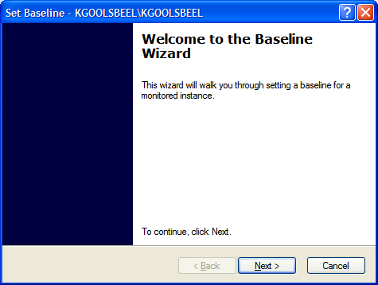
Page 1: Intro
A button (not pictured) will be added to the intro page that will allow the user to start the baseline wizard. We will add text to the dialog to draw attention to the button when one or more metrics for the selected server have no baseline data set. If there is no baseline data for any of the metrics the next button will not be enabled. If the user selects the baseline button the Baseline Wizard will start in a separate dialog.
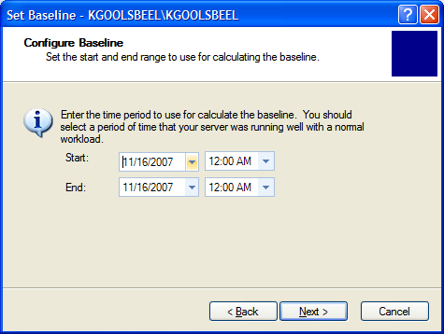

Page 2: Prompt for start and end dates for the datapoints used to calculate the baseline. .

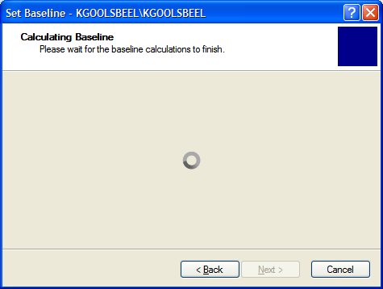
Page 3: Something to look at while the user is waiting for the baseline to be assembled.
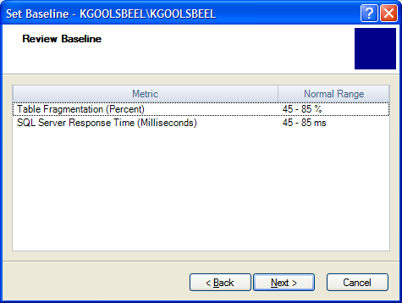

Page 4: Display a grid showing the normal range from the baseline for all supported metrics that were calculated.

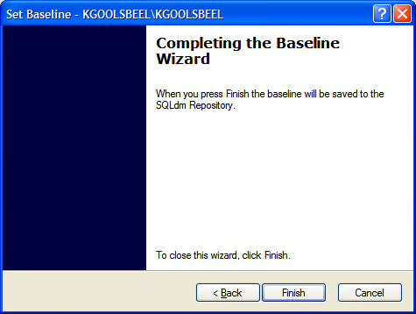
Page 5: Summary
When the user hits finish the parameters used to calculate the baseline and the baseline values will get stored in the repository. If the user started the wizard from the alert configuration dialog the new baseline values will be shown in the blue bar on the slider.

Set Alert Thresholds From Baseline
The Set Alert Thresholds From Baseline Wizard will allow the user to quickly set their alert configuration for one or all of their metrics using data from the baseline.

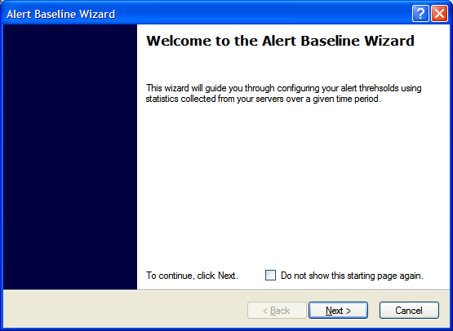
Page 1: Intro
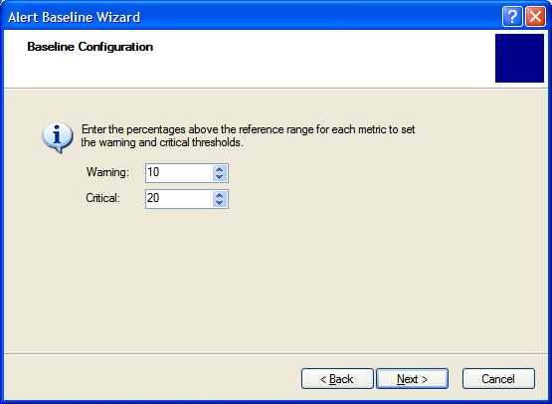
Page 2: Configure the threshold calculation percentages. The warning and critical thresholds will be calculated as a percentage above the average plus the one standard deviation of the values collected during the baseline period for each metric.
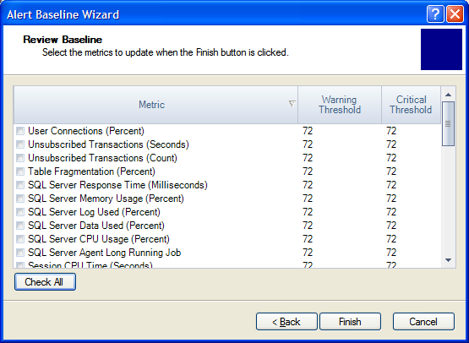
Page 3: The Select Metrics to Update page allows the users to preview the calculated threshold values and select which ones will be updated. By default all the items will be checked. The Finish button will be changes to ‘Save’.
When the user presses save the baseline values will be saved in the repository and the user will be returned to the place that they started the dialog.

Installation and Upgrade
An upgrade of the repository will be required due to an tables needed to store the baseline data.

Permissions and other Required Configuration
If we add the feature for Application Security in 5.1 then we will need to make sure the actions for setting the alert configuration are only available for users with Full-Access or Administrator privileges.

Licensing Issues
None.

Dependencies

Dependencies on Idera Software
No additional dependencies.

Third-Party Software Required on the Customer Machine
No additional dependencies.

Third-Party Software Required Internally
No additional dependencies.

Internal Design

Architecture

Repository Changes
A new table and supporting procs will be created to store and query the baseline values for a server.
The monitored sql server table will be changed to store the values used to calculate the baseline.
A stored proc will be needed to calculate the baseline value resultset. We will return the average and the standard deviation of the each value over the selected time range. We will also need a proc to store a baseline in the repository.

Management Service
The Management Service will need to expose a method for storing a baseline for one or more monitored servers.

Collection Service
No changes required.

Alert Configuration Dialog
The Alert Configuration Dialog will require a new button used to launch the Baseline Wizard. The button will be placed under the list of Metrics next to the Set as Default Button.
A new column will be displayed in the thresholds grid to show the suggested value calculated from the baseline. The column will contain blanks if a baseline is not available for the server.
The objects that are bound to the threshold value will need to be changed to provide the data necessary to display in the reference range column. Changes as a result of the baseline wizard will need to use the methods on the bound objects so that the Alert Configuration Dialog can identify when values have changed.

Baseline Wizard
The Baseline Wizard will get launched by clicking a button on the Alert Configuration Dialog.
Page 1 will show some intro text.
Page 2 will display the start and end times to use for selecting the collected statistics used to calculate the baseline. We will show the values used the last time a baseline was calculated for the selected server. If no baseline has ever been calculated then the previous 2 weeks will be used.
When the user clicks Next on Page 2 the baseline will be calculated and displayed on Page 3.
Page 3 will display a grid of the metrics that support baselining and their reference range. When the user clicks Next the Summary page is displayed.
When the user presses Finish the baseline values for the server are sent to the Management Service for storage in the Repository.
If the user clicks Cancel, at any time, nothing is changed.

Set Thresholds using Baseline Wizard
The Set Thresholds using Baseline Wizard gets launched by clicking a button on the Alert Configuration Dialog.
Page 1 will show some intro text and a button will be available to launch the Baseline Wizard. An info label will be used to instruct the user on why the button is there.
Page 2 will also allow the user to specify the percentage over the upper bound of the reference range to use for calculating the warning and critical thresholds. If no baseline has ever been calculated then warning will be 10% and critical will be 20%.
Warning = Avg(Metric) + Stdev(Metric) + (Avg(Metric) + Stdev(Metric)) * WarningPercent / 100
Critical = Avg(Metric) + Stdev(Metric) + (Avg(Metric) + Stdev(Metric)) * CriticalPercent / 100
Page 3 will display all the supported metrics and the newly calculated threshold values. The user can select (using checkboxes) which metrics to accept when the user clicks finish. The checked metrics will update the values in the alert configuration dialog. Nothing is written to the repository when the user finishes with this wizard.

Installation Issues
The repository will require an upgrade.

Schedule

Work Breakdown and Sizings
Component | Who | Sizing
Management Service | Kurt | 1
Collection Service
Database | Kurt | 2
Desktop Client | Kurt | 4
Unit and Integration Testing | Kurt | 1
Total |  | 8

Areas of Risk
Custom counters may complicate the changes necessary to support this feature.

Quality Assurance Considerations

Overview
This feature does not change the way that alerting works, it only provides suggestions based on collected statistics. The user has to take action for the suggestions to overwrite the currently configured values.

Developer-Created Unit Tests
The baseline related buttons and the baseline bar on the slider should not be available on the default alert configuration.
Make changes to the alert configuration using the set alert using baseline wizard. Click cancel – no changes should have been saved.
Make changes to the alert configuration using the set alert using baseline wizard. Click finish – changes should be visible in the alert configuration dialog. Click OK. Changes should be persisted to the repository.
Make changes to the alert configuration using the set alert using baseline wizard. Click finish – changes should be visible in the alert configuration dialog. Click cancel. No changes to the alert configuration should be persisted to the repository.
After performing prior step, if you start the alert configuration dialog again, you should see suggestions created by the last run of the baseline wizard.

